1. **Perform Sharpening of Image using High-Boost Masks.**

**Aim:**

To perform Sharpening of Image using High-Boost Masks.

**Code:**

**Input:**

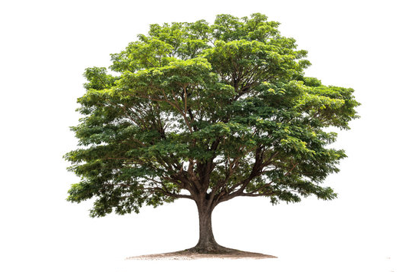

**Output:**

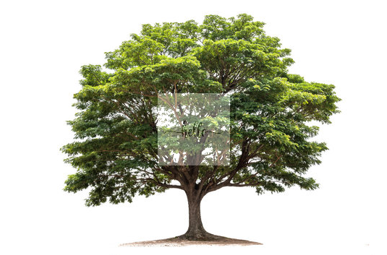

**Result:**

The python code to perform Sharpening of Image using High-Boost Masks has been executed successfully.